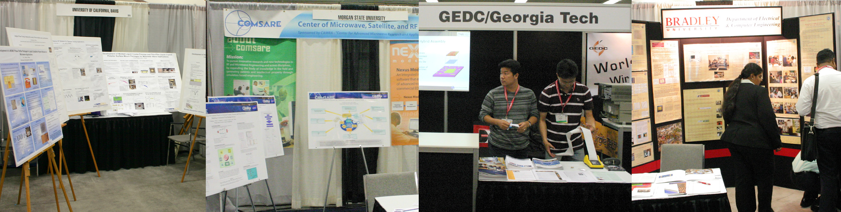

IMS 2007 University Exhibits

Why Should I Sign-up?
- IMS 2007 is the world’s premier microwave conference
- 10,000 attendees from around the world
- University booth space is provided free of charge
- Proudly display your research to the microwave community

Who is Eligible?
- All universities worldwide

How do I sign-up?
- Complete the University Exhibits Request Form
- Email the completed form to Grant Shiroma no later than Thursday, March 1, 2007

IMS 2007 University Exhibits Request Form

E-mail this form to Grant Shiroma: grant.shiroma@hawaii.edu no later than Mar. 1, 2007.

Contact Name | Professor’s Name (if different from contact)
University

I would like to request (please select one):

A. Full Booth (10’ wide by 10’ deep)

B. Shared Half Booth – I would like to share with:

Professor’s Name

University

C. Shared Half Booth – Please assign me someone to share with.

Please provide your mailing address

ADDRESS

CITY | STATE/PROVINCE | COUNTRY
ZIPCODE | TELEPHONE | FAX

Cost of booth furnishings is extra.
Promotion or sale of products in a university booth is strictly forbidden. Applications for regular booth space may be obtained from www.ims2007.org.
Due to a limited availability of university booth spaces, we cannot guarantee that all requests will be fulfilled.

